Query 1:

Click on “Query 1” button to get the list of galleries

Query 2:

Mention the Gallery name in the “gallery Name” field and click on ‘Query 2’ button



Query 3:

Mention the Gallery name in the “gallery Name” field and click on ‘Query 3’ button. The details can be seen by clicking in the Image.

Query 4:

Mention the Gallery name in the “gallery Name” field and click on ‘Query 3’ button. The details can be seen by clicking in the Image.

Then Click on the artist name to get the details of the artist.

Query 5:

Click on ‘Query 5’ button. Enter the details and click on submit. The new gallery will be created.

Query 6:

Click on ‘Query 6’ button. Enter the details and click on submit. The new artist will be created.

Query 7:

Click on ‘Query 6’ button. Enter the details and click on submit. The new artist will be created.

Query 10:

Click on ‘Query 10’ button. Enter the artist name and enter the parameters to be modified. Click on submit. The entered details will be updated in the artist table.

Query 11:

Click on ‘Query 11’ button. Enter the gallery name and enter the parameters to be modified. Click on submit. The entered details will be updated in the gallery table.

Query 12:



Enter the type of image and then click on Query 12 button.

Query 13:

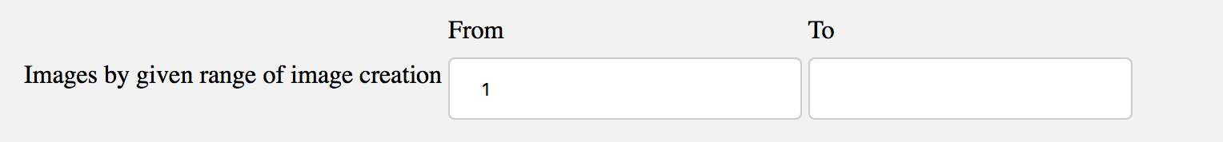

Enter both the parameters to get the list can then click on Query 13 buttin. Other No results will be displayed.

Query 14:

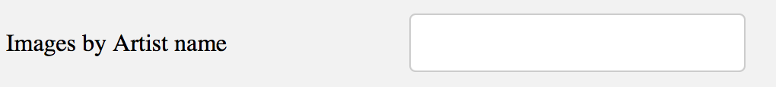

Enter the name of the artist and then click on Query 14 button. The results will be displayed.

Query 15:



Enter the images by location and tehn click on Query15 button.

Query 16:

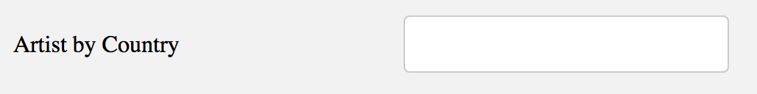

Enter the name of the country. Click on Query16 button. The results will be displayed.

Query 17:



Enter the year. Click on Query17 button to get the results.

**Extra Credit A:**

Click on **ExtraCredit A** button. Click on the image to see the list of the images in the gallery.

**Extra Credit B”**

Click on ExtraCredit B button. Upload the file by clicking on the browse button and then click the submit button.

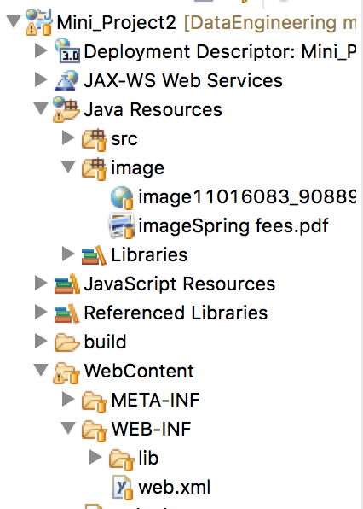

Click on the web.xml file and change the folder location of the image folder. The path can be given in between the tabs of <param-value>…</param-value>.

